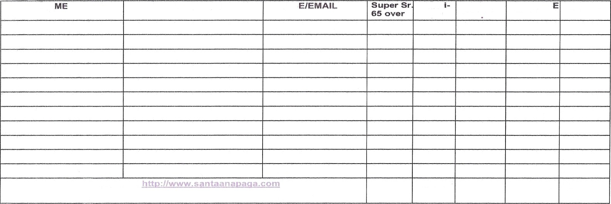
NA
ADDRESS
PHON
Hand
ENTRY
^a
P
230 OO
PRACTIC GO.OO ea.
YOTAL
Website:
TOTALS

THE SANTA ANA CHAPTER OF THE PAN AMERICAN GOLF ASSOCIATION
%
> *
HOSTS THE 2021 LAN/GHLIN SCHOLARSHIP INVITATIONAL APRIL 15'h, 16" and 17'h, 2021
*All Entries Must Be Received by March 22, 2021*

Make Checks Payable to: PAGA Santa Ana ENTRY FEE IS $230.00 PER PLAYER
A practice round is available for Thursday or Friday - $60.00 entry fee each day
Mail Entry Fees Along with This Application to: PAGA Santa Ana, P. O. Box 4215, Santa Ana, CA 92702 For More Information Call Luis Gutierrez at (714) 538-2268 or Email To:
PAGA CHAPTER Contact Person Phone

